Factorial of a given number:

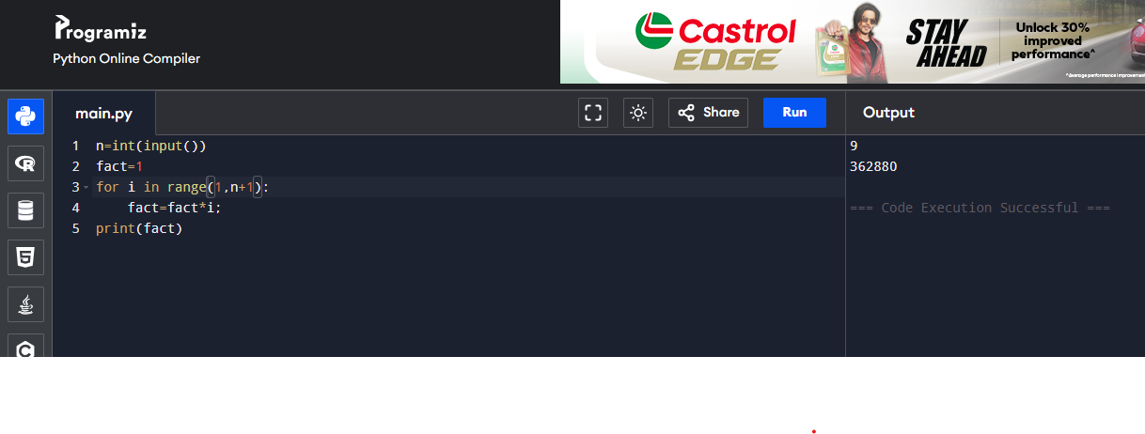

Even or odd:

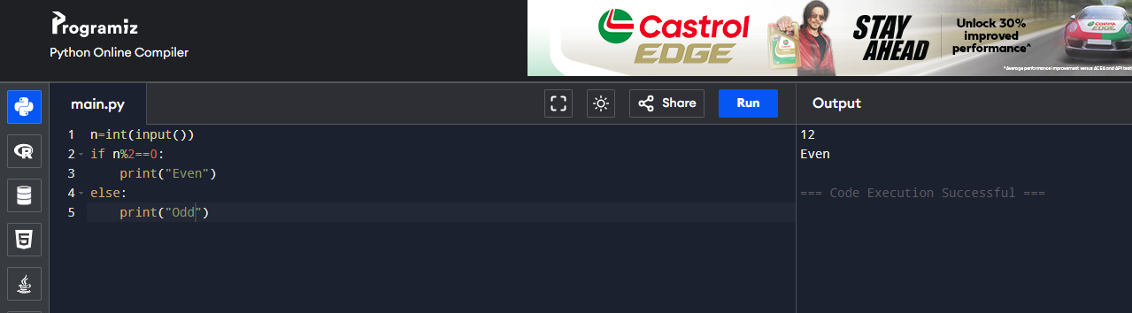

Palindrome or not:

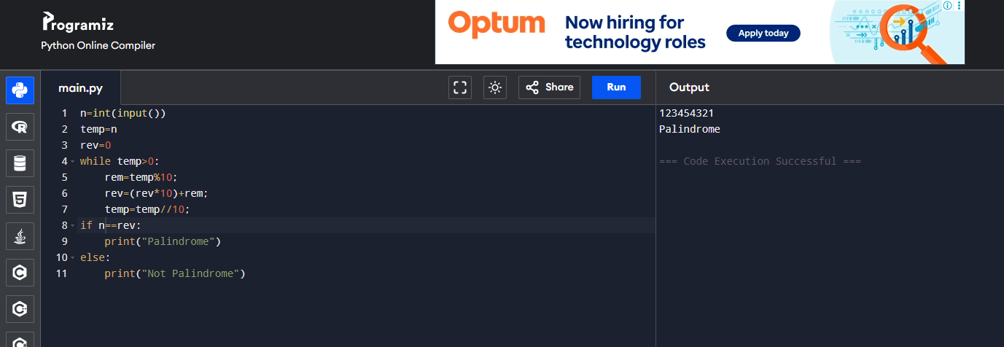

Prime or not:



Pronic or not:

